# **VR Tour - Man and the Living World Museum**

**Detailed Design**

**Performed By:**

**Bar Yaron – 206481533**

**Yakir Zafrani – 313327496**

**Project Director – Dr. Sharon Yalov Handzel**

Table of Contents

Scope 3

Use Cases 3

User navigates through the VR museum environment: 3

User interacts with exhibits: 3

User accesses exhibit information: 3

Admin manages exhibit database: 4

Detailed Design 5

System Architecture 5

Performance 5

Data 5

Integration 5

User Experience 5

Scalability 6

Security 6

Technological Requirements 7

Programming Languages and tools 7

VR Hardware Platforms 7

3D Modeling and Animation Tools: 7

Development Tools 7

Documentation Standards 7

Block Diagram 8

DB Scheme 8

Mockup 9

DB side 9

Unity side 10

# Scope

This document describes the system architecture, application use cases, and technological requirements of the VR tour project for our client - Man and the Living World Museum.

# Use Cases

## User navigates through the VR museum environment:

* User puts on the VR headset and enters the virtual museum environment.
* Within the VR environment, the user can look around and move using VR controllers or keyboard/mouse inputs.
* The user can explore different sections of the museum, such as galleries, hallways, and exhibition rooms, by walking or teleporting within the virtual space.

## User interacts with exhibits:

* While exploring the museum, the user encounters interactive exhibits represented by 3D models or artifacts.
* The user can approach an exhibit and use VR interactions to select, examine, or interact with objects within the exhibit.
* For example, the user can pick up a virtual artifact, rotate it, zoom in to examine details, or trigger animations or audiovisual presentations associated with the exhibit.

## User accesses exhibit information:

* Upon interacting with an exhibit, the user can access detailed information about it.
* Information panels or overlays within the VR environment provide descriptions, historical context, multimedia content (e.g., images, videos), and related articles or resources associated with the exhibit.
* Users can engage with this information to enhance their understanding and appreciation of the exhibit's significance and relevance.

## Admin manages exhibit database:

* Admin users have access to backend tools or interfaces for managing the exhibit database.
* Admins can add new exhibits to the database, providing metadata such as exhibit name, description, location, and associated multimedia content.
* They can edit existing exhibit information, update multimedia assets, or remove outdated exhibits from the database as needed.

# Detailed Design

## System Architecture

The system architecture of the VR museum application may include the following components:

* Client-side VR application developed using Unity for immersive user experience.
* MySQL database for storing and managing exhibit data, metadata, and user interactions.
* Communication protocols (e.g., HTTP, WebSockets) for interaction between client and server components.

## Performance

* VR application should maintain a consistent frame rate (e.g., 60 - 90 FPS) for smooth user experience.
* Database queries should execute within milliseconds to ensure quick retrieval of exhibit information.
* Loading times for exhibits and database interactions should be minimal to avoid user frustration.
* Server-side components should be scalable to handle increasing user traffic and database load.

## Data

* The system shall utilize a distributed database architecture, ensuring data consistency between the museum managers contents and the 3d VR environment.
* MySQL database schema should include tables for exhibits, exhibit metadata, user interactions, and user profiles.
* Exhibit data should include attributes such as exhibit name, description, location, and associated multimedia content.
* Database should support relational queries and indexing for efficient data retrieval and management.

## Integration

* The unity engine shall integrate with the MySQL database to import 2D exhibits from the database into a designated area in the 3D VR environment using industry-standard APIs.

## User Experience

* Realistic and immersive 3D environments that closely resemble the physical museum.
* Accessible features for users with disabilities, including alternative navigation options and audio descriptions.
* Onboarding tutorials or guided tours to help users familiarize themselves with VR controls and features.

## Scalability

* Application architecture will be designed for horizontal scalability to accommodate increasing user traffic and database load.
* VR museum application should be implemented as dynamically as possible in unity, to allow project growth as the museum and its contents evolve.

## Security

* User Identification for database access by logging in with a username and password, in basic token, listed users will be managed in a table in the database.
* Security level to restrict access to the database from different users, users could only perform SELECT, UPDATE, and INSERT operations, will be managed in a table in the database.

# Technological Requirements

### Programming Languages and tools

* C# (C - Sharp) – for programming in the unity engine and implementing the VR environment along with all of its features.
* XR Plugin – A built in library for unity VR development.
* MySQL - for database querying and data manipulation.
* JavaScript – for creating a UI application to interface the DB.
* HTML - for web page development.
* HTTP/HTTPS for API endpoints for client-server communication.

### VR Hardware Platforms

* Oculus Rift, Oculus Quest (compatible with quest 1, quest 2, and quest 3).
* Compatible VR controllers for user interaction.

### 3D Modeling and Animation Tools:

* Blender, for creating 3D models or using unity asset store / other sources for 3D models and assets.

### Development Tools

* Git for version control and collaborative development.
* GitHub for hosting and managing code repositories in unity.
* Unity version 2021.3 LTS – for VR application development.
* Microsoft Visual Studio 2022 – IDE for C# scripts that will run in Unity.
* Postman – for web API.
* Java Spring Boot - for DB server infrastructure.
* JetBrains’s intellij IDEA – for implementing Java Spring Boot.

### Documentation Standards

* Unity design patterns for clean code and scalable project infrastructure.
* Clear and scalable DB architecture.

# Block Diagram

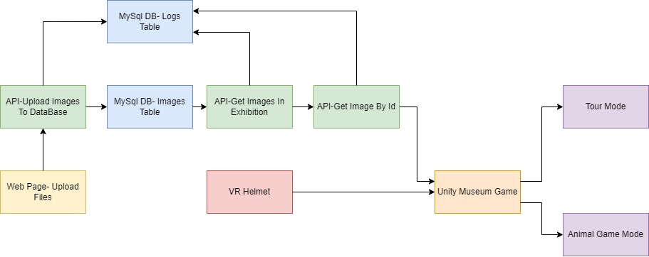

# DB Scheme

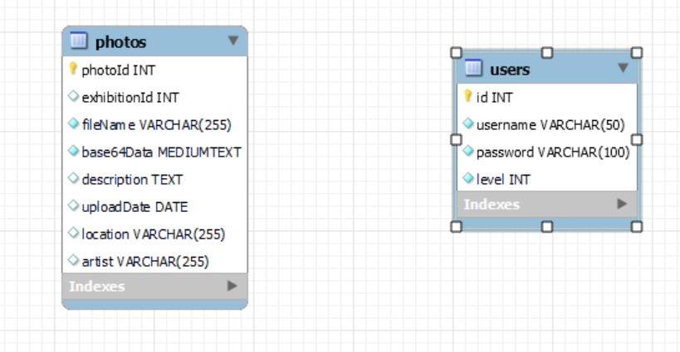

### Mockup

### DB side

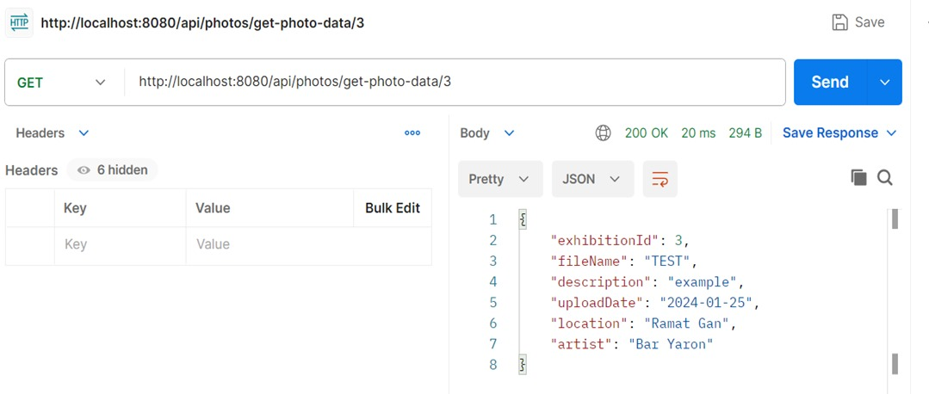

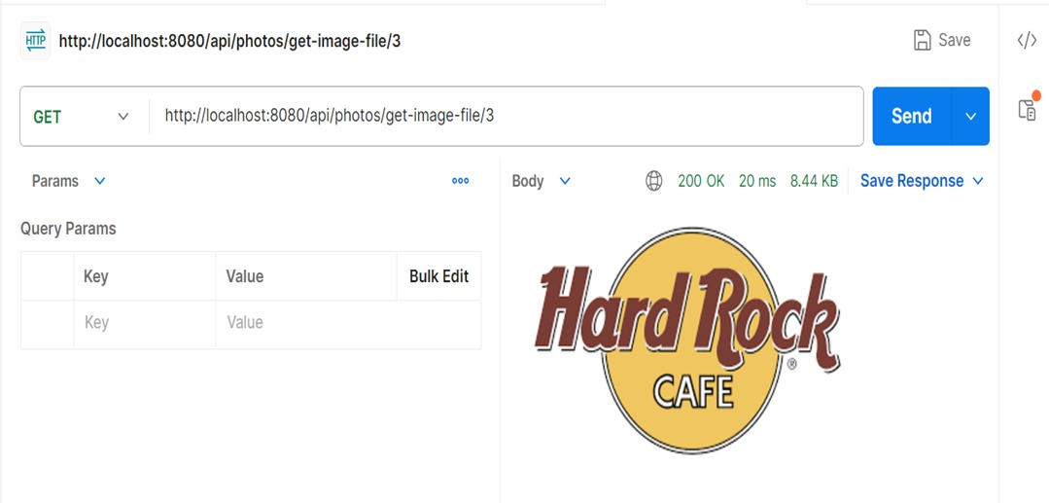

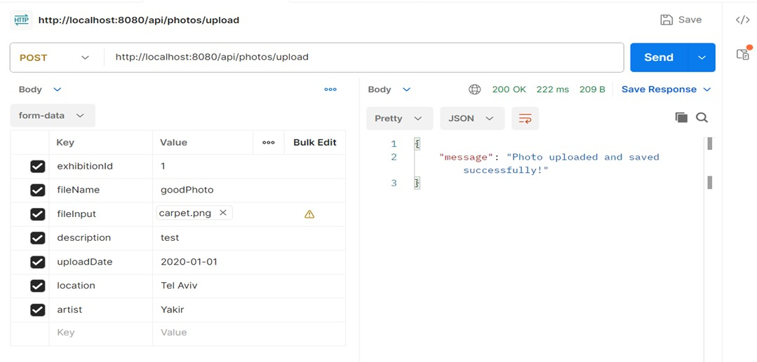

### Unity side

Will be added as development continues.